**Session 0 - Downloading Software, Creating an Account, and Setting up your Workspace**

Welcome to the Intro to Data Analysis in R* Series! This 6-part series will introduce you to basic coding concepts in the R software language for the purpose of data analysis. While the series will focus on using R for data analysis, the concepts learned from this course will introduce participants to universal coding concepts which can be used to perform functions outside of data analysis and are transferable to other coding languages. By the end of this series, a participant can expect to know how to import data from an online source using an API, clean and merge the dataset with existing dataframes, write functions to transform the data and prepare for analysis, calculate summary statistics using R, and visualize the data based on variables/groups of interest.

Let’s get started!

Before we meet for the first session, we’ll need to download and install R and set up our **integrated development environment (IDE)** - this is essentially the interface or program we will use to code on our computers (think using Microsoft Word as your text editor). There are many IDEs to choose from and the difference between them all really comes down to your preference. Through CAP, we have two pre-approved IDEs we can choose from - **R Studio** and **Visual Studio Code (VS Code)**. We’ll be leading all demonstrations in R Studio, so I recommend using that one (it’s also my preferred IDE for R).

**First, let’s download and install the R software and RStudio:**

* **Installation:**
* For Mac Users:
  + [Refer to the Confluence page for help](https://americanprogress.atlassian.net/wiki/spaces/ITKB/pages/63767136/Installing+Software+Applications+using+MacManage)
  + Open MacManage from your desktop’s menu bar

* Scroll down and install R and R Studio

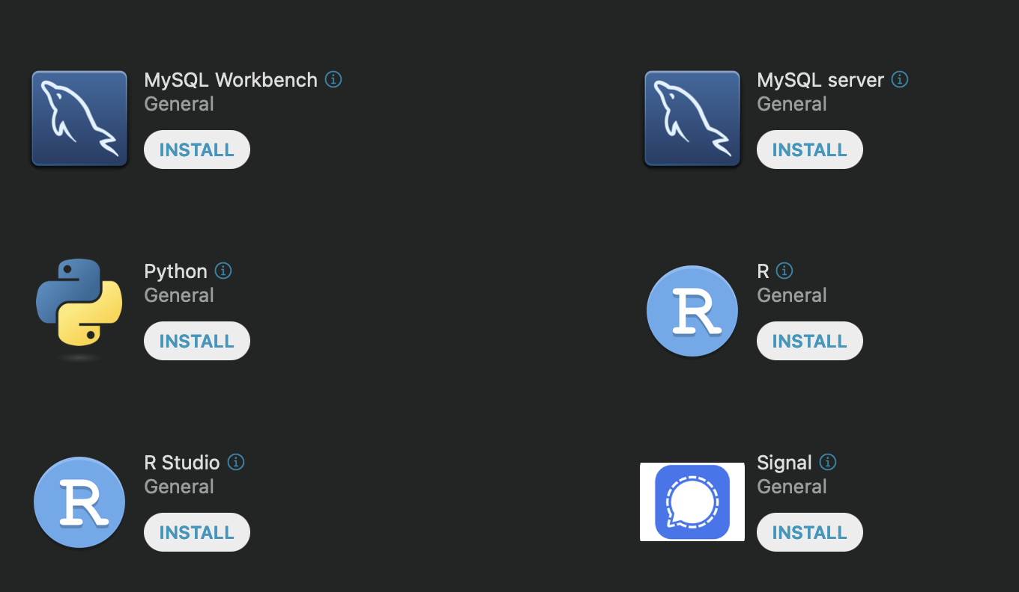





* For PC Users:
  + [Refer to the Confluence Page for help](https://americanprogress.atlassian.net/wiki/spaces/ITKB/pages/63767485/Installing+Software+Applications+using+the+Company+Portal)
  + From your desktop’s **Start** menu, launch **Company Portal**

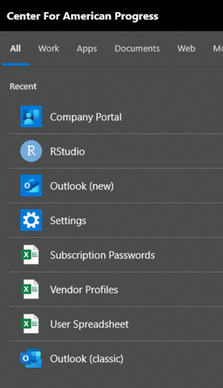



* + Go to the **Apps** menu and search **R for Windows,** then install

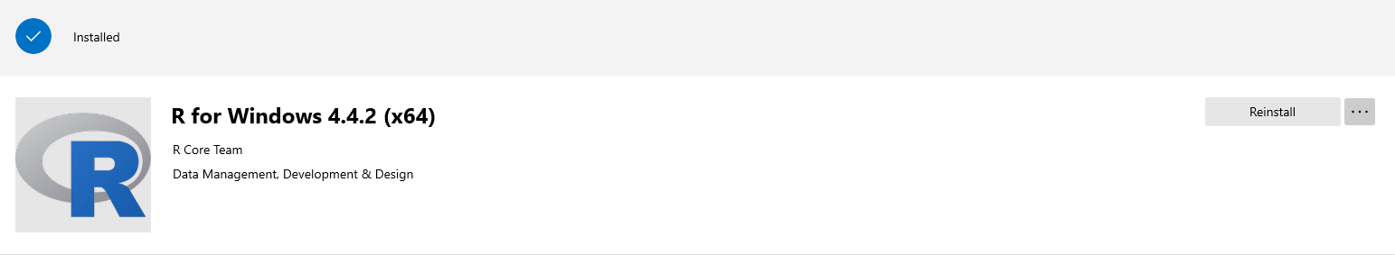



* + Once R is installed, search the **Apps** menu again for **RStudio**, and install

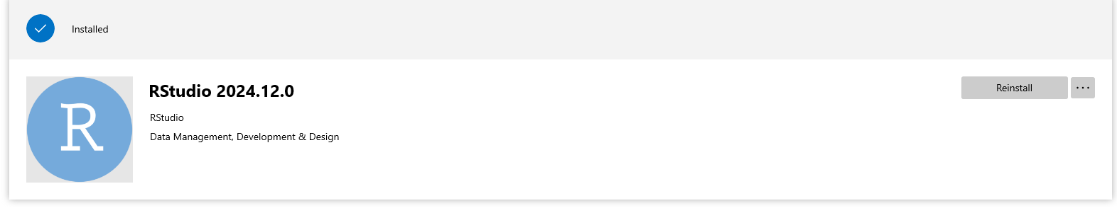

* + When both programs are installed, open **RStudio** by searching in your **Start** menu from your desktop
  + The first time you open RStudio, it will prompt you about the processor, choose to use the default 64-bit processor

You’re now ready to start coding!

**How to Setup GitHub:**

* **Create a Github account:**
  + On your browser, go to <https://github.com/>
  + Click on **Sign Up** in the upper right of your screen and create a new account with your CAP email address and a unique Github account name
  + When you have created your account, please submit your Github Username [here](https://forms.gle/c3HMiLkZvLN38EVz6)
* **Install Github Desktop:**
* **Clone Workshop Repository:**
  + Go to [github.com/challCAP/Intro_to_R](http://github.com/challCAP/Intro_to_R)
  + Click on the arrow on the green button that reads **“<> Code”**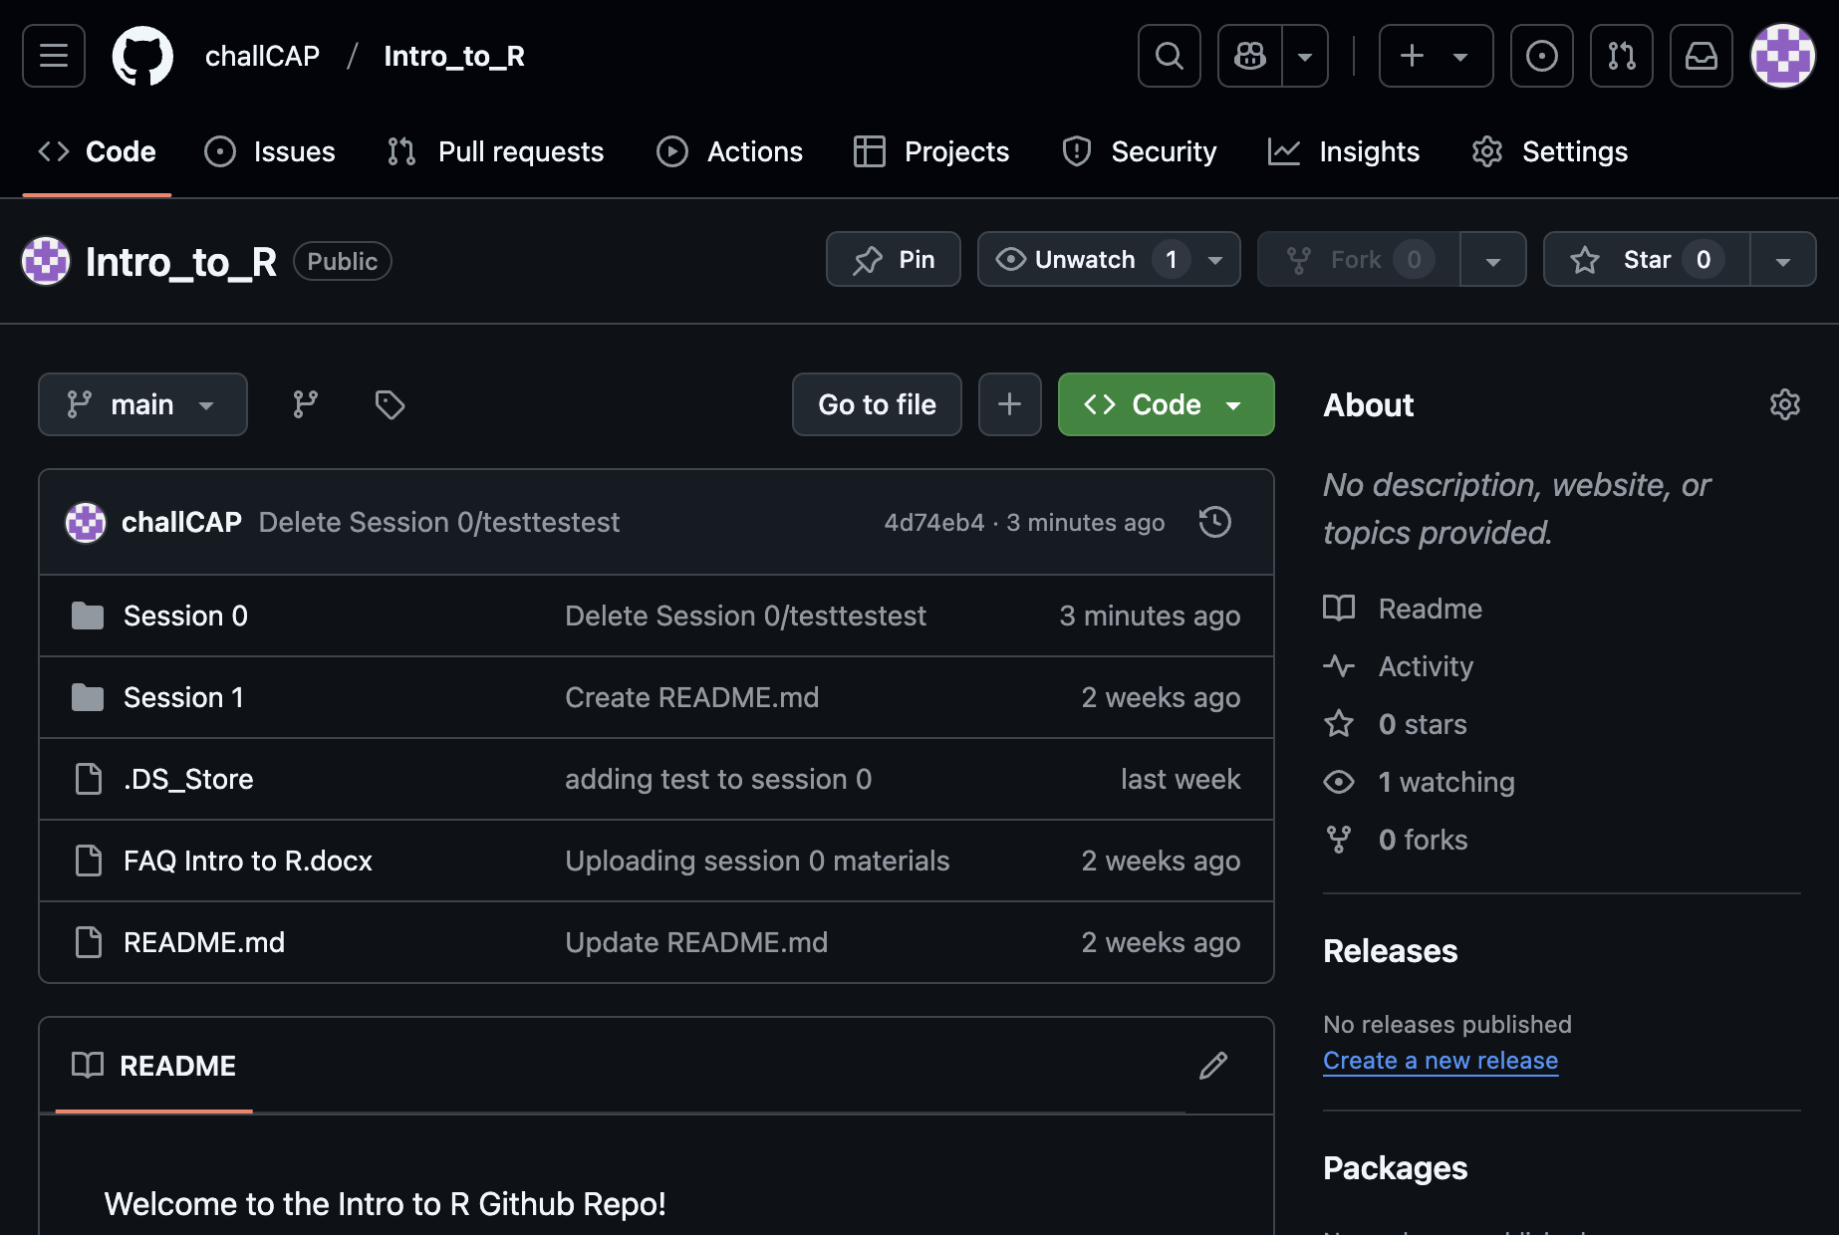



* + From the menu, select **“Open with Github Desktop”**

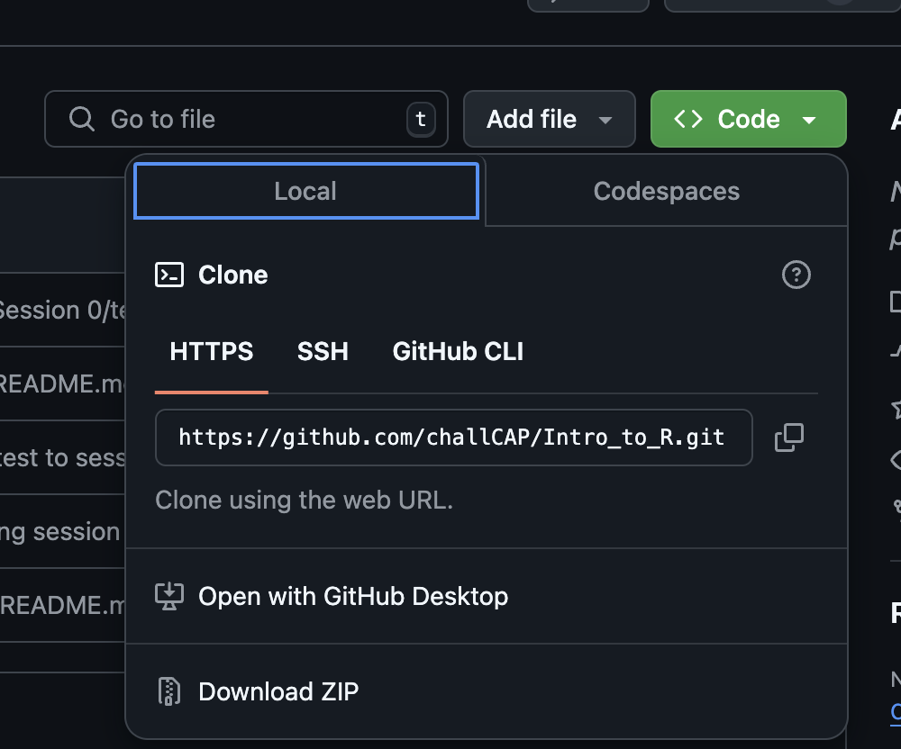

* + This will open your Github Desktop application with a prompt that looks like this:

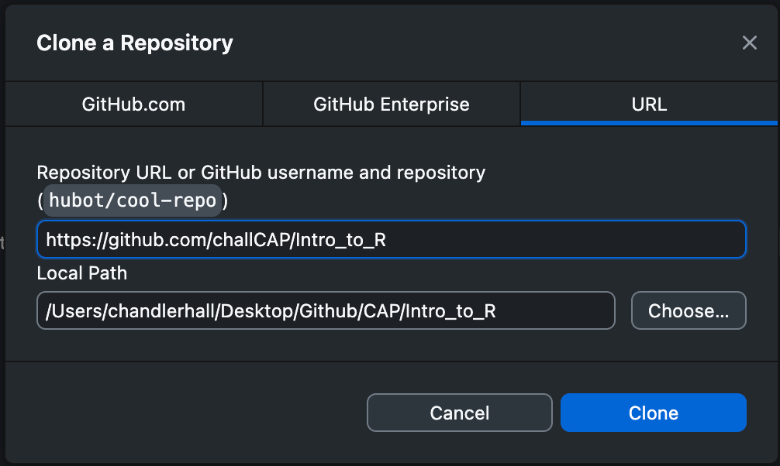

* + **PAY ATTENTION** to the local path you are creating! Make sure you are organizing your repos in a place that makes sense for your organization long-term. For me, I have chosen to make a Github folder, which stores all my repos, with a CAP subfolder with all my CAP related projects, and then the Intro to R folder lives in there.
    - If you are unfamiliar with pathing, I would recommend clicking “choose” and navigate to where you want to locate this Intro to R folder accordingly
  + Once you have selected your local path, click “clone” and you’re all set!
  + From your desktop, try locating the folder - you’ll see that it’s already populated with the workshop materials you need!

**Confirm Everything is Working:**

* Now that you’ve located your repo on your local computer, go to **Session 0** and open the file named **“setup_test.R”**
* This should automatically open **RStudio** on your computer and the **R script** of the same name
* On the toolbar at the top of your screen, select **Code > Run Region > Run All**
* What did you get as the sum?
  + answer should be **1036**

**Please reach out to Chandler at** [**chall@americanprogress.org**](mailto:chall@americanprogress.org) **if you have any questions or have run into any issues BEFORE Session 1**